Cosmos – Well order universe -

Cosmos Db is planet No sql Json db with multi api

Latency –

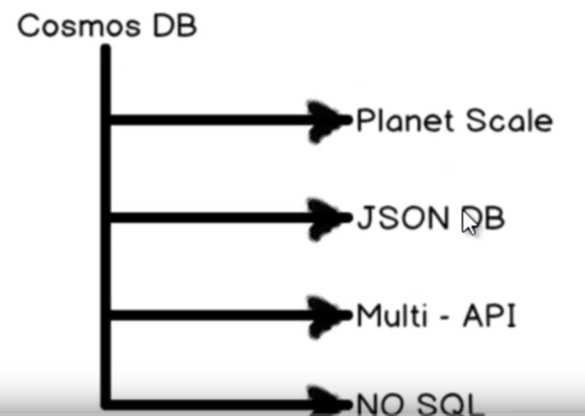

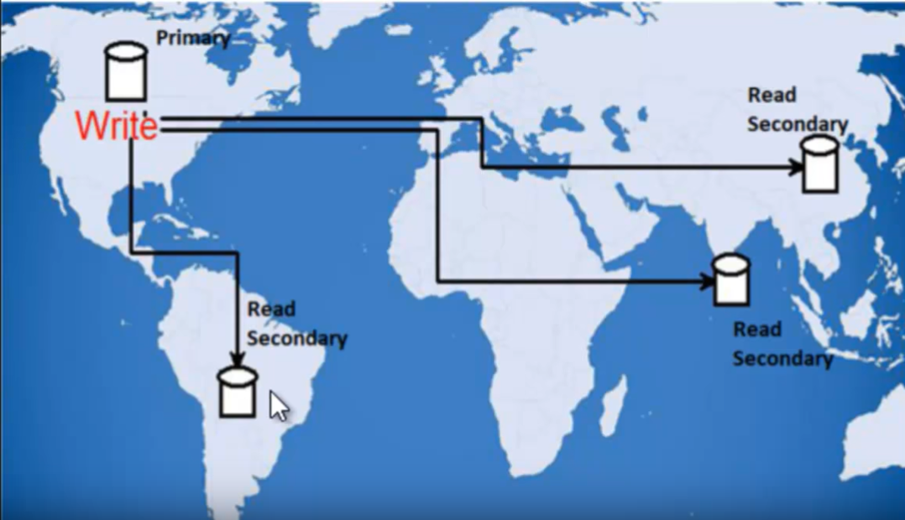

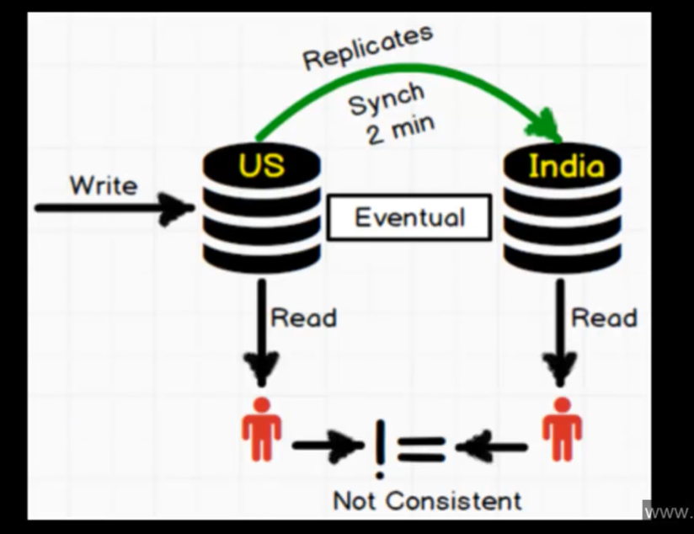

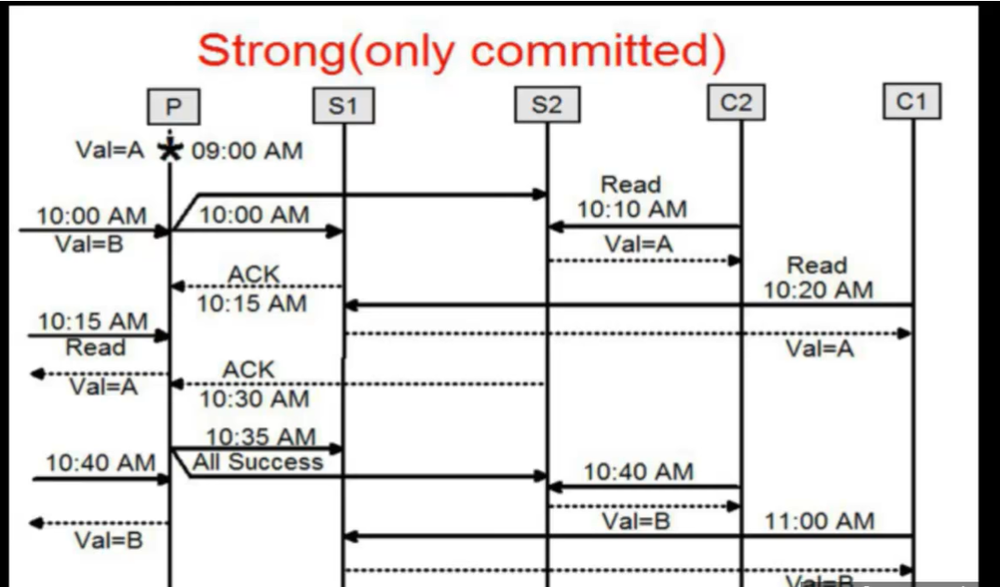

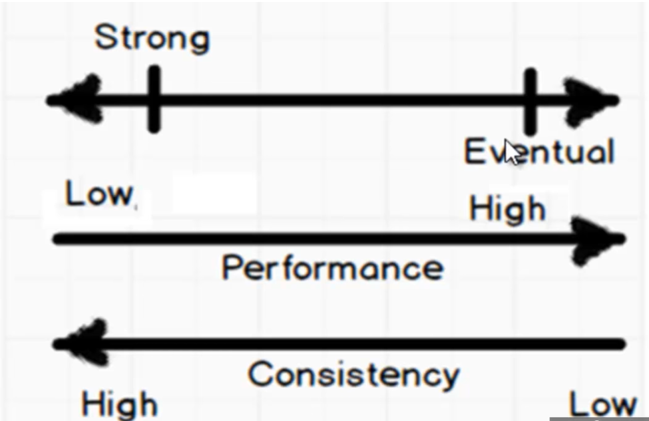

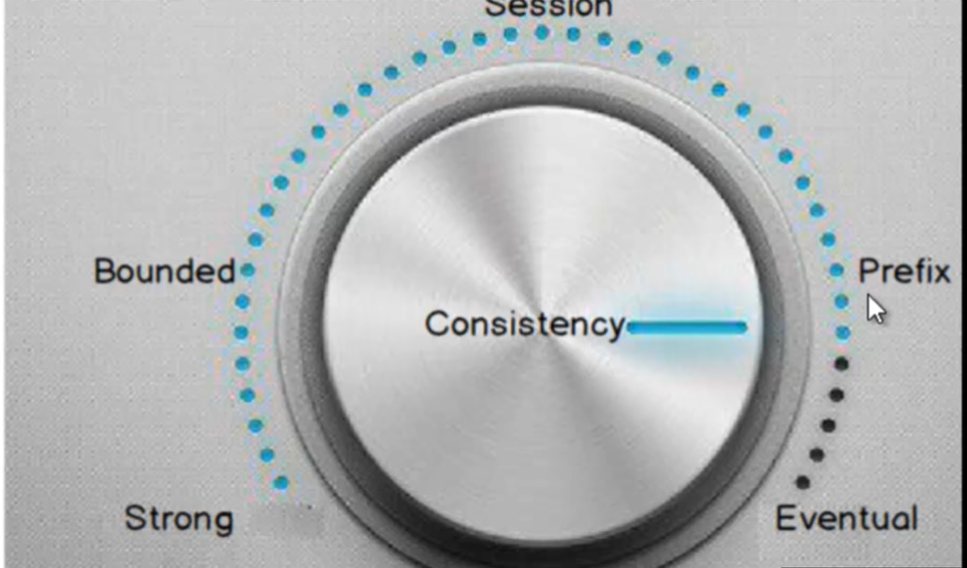

Bounded Consistency - A specific interval is set so every location gives new value after specific interval of time.

Note - Interval = 0 means strong consistency

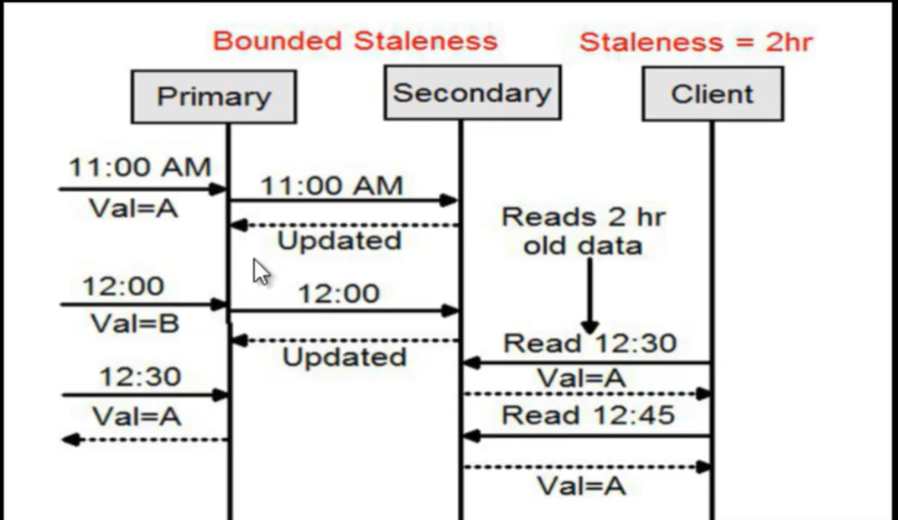

**Session Consistency**

A committed user can see the updated value after synchronization every user can reads the updated data.

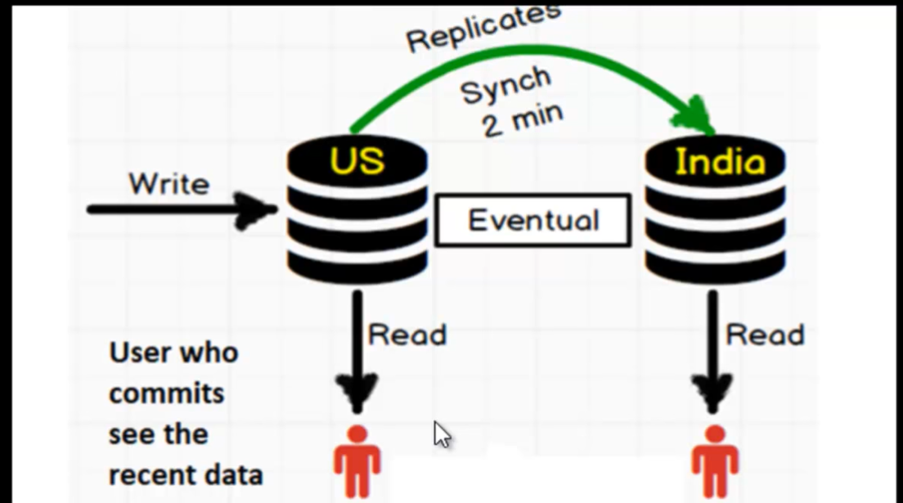

Prefix Consistency

After synchronization user reads the data as the order they committed.

